Geologic History/Correlation/Relative Dating

Name:_____________________________ Block:_________________ Partner:___________________

Intro: Geologists can determine the relative ages of the rock layers in a rock formation. But how do they determine whether the rocks or geologic events occurring at one location are of the same age as those at another location? The process of showing that rocks or geologic events occurring at different locations are of the same age is called correlation. Geologists have developed a system for correlating rocks by looking for similarities in composition and rock layer sequences at different locations. Certain fossils, called index fossils, existed for a very short time and were distributed over a large geographic area. They aid the geologist in correlating sedimentary rock layers.

Objective: You will be able to construct a geologic history of a region by observing rock layers in different localities.

Pre-Lab Questions:

- What is a rock sequence?

- What is an index fossil?

- Typically speaking, do you think it would be easier to correlate rock layers with or without fossils? Explain why

- Other than the ordering of rock types in a sequence or the presence of fossils, can anything else be used to correlate rock layers?

Procedure A: The first set of four diagrams represent four outcrops at different locations.
- Reconstruct the complete sequence of events. Assume that the oldest rocks are on the bottom and the youngest are on top. Draw lines between the layers to help you correlate (match) them.

- Draw your interpretation of the layers on the appropriate column to the right (oldest on the bottom, youngest on top)
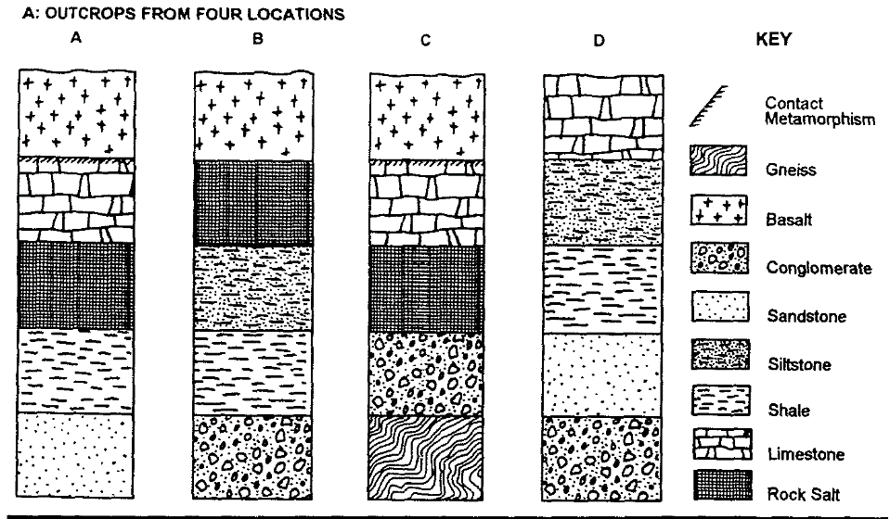

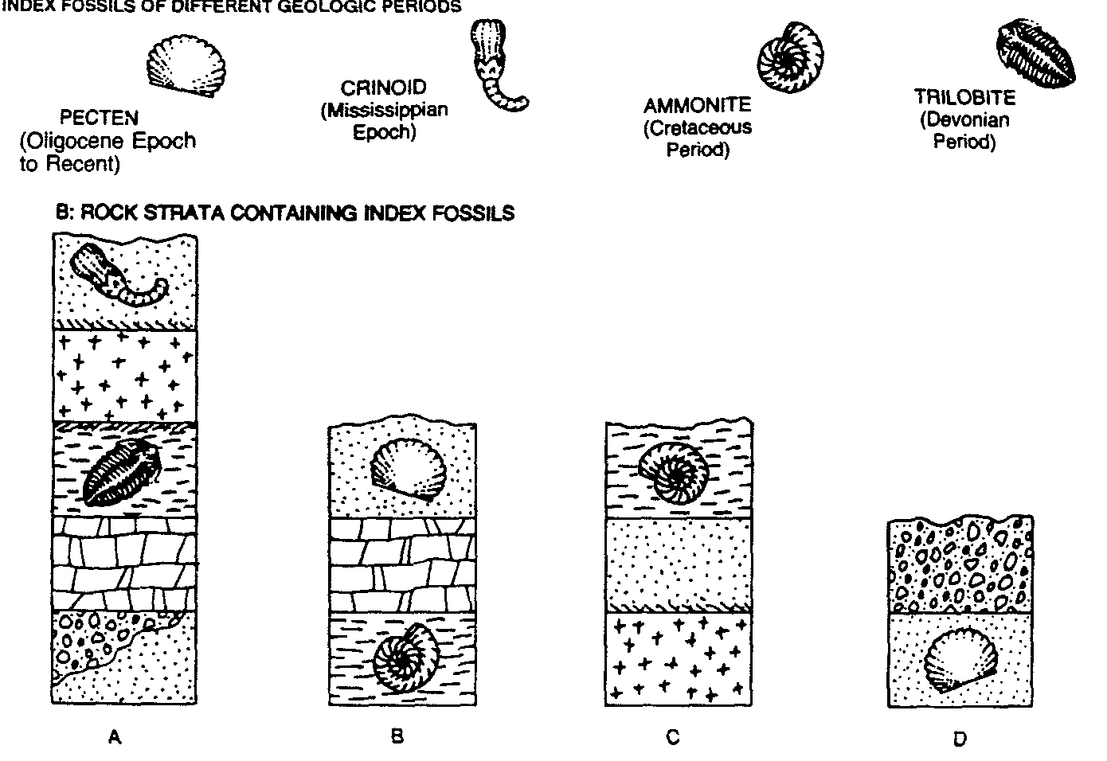

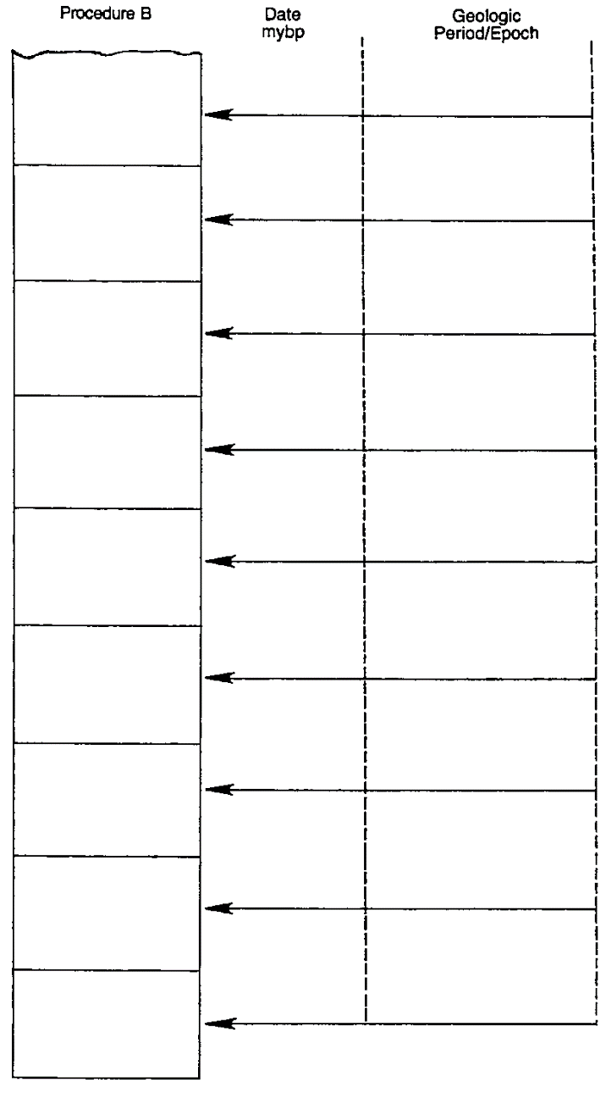

Procedure B: The second set of diagrams identifies four types of index fossils and shows four columns of fossil bearing rock strata. Assume overturning has not occurred.
- Reconstruct the complete sequence of events. Draw lines to correlate your layers
- Draw the layers (with the fossils if present) on the appropriate column to the right.
- By referring to your Reference Tables, identify any layer for which you have enough evidence to determine its numerical age. On the Report Sheet, label its age and period/epoch. The
abbreviation “mybp” stands for millions of years before present. It may be expressed as a range of several million years.

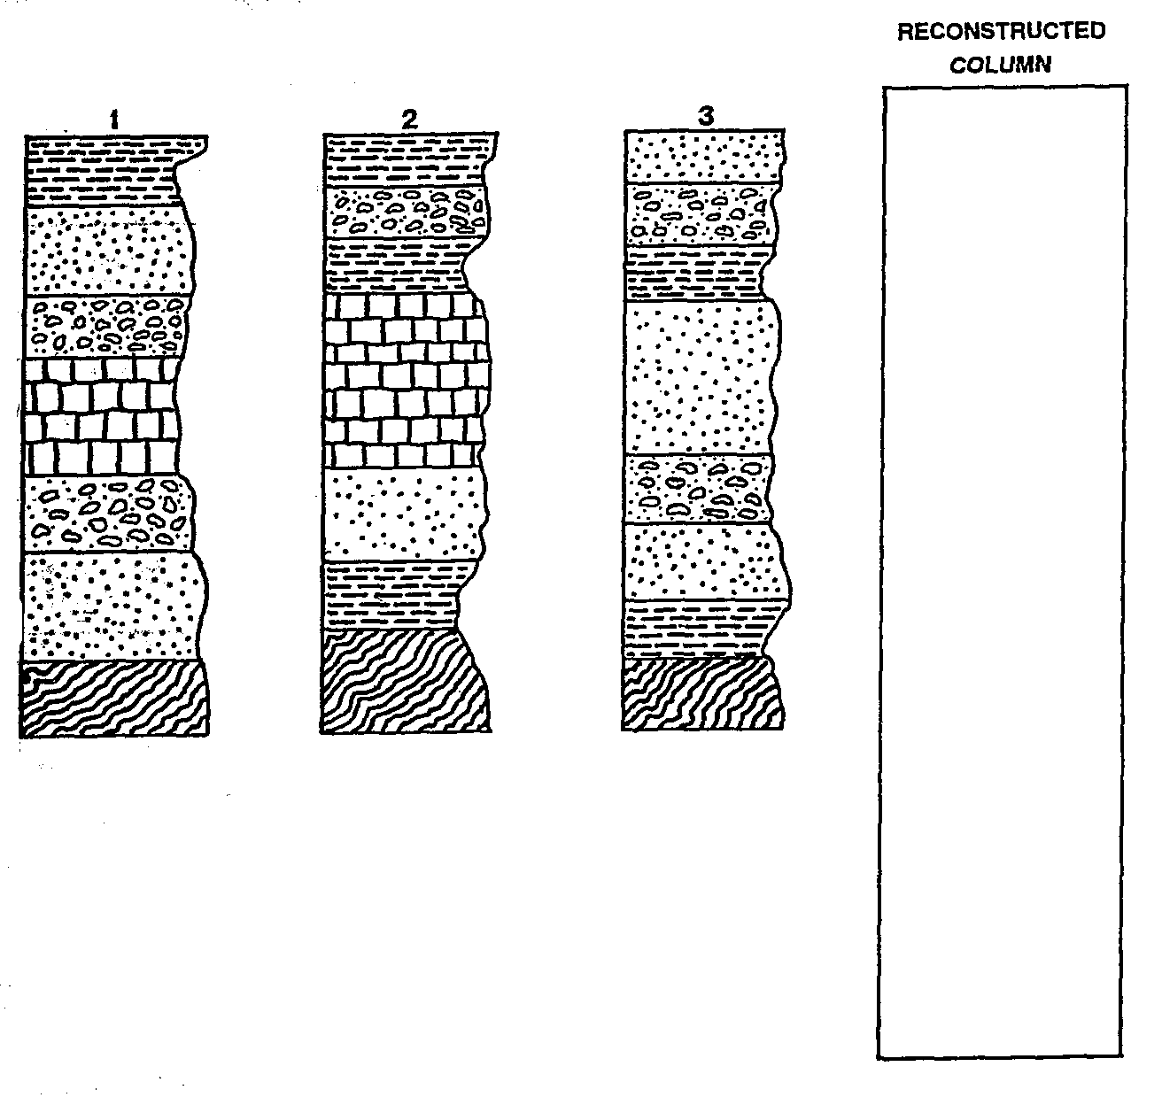
Procedure C:
The third set of diagrams represent three
different outcrops. Using the rock type
of the strata correlate the columns.
- Draw lines representing
equivalent boundaries between
rock layers from one column
to the next.
- Reconstruct the complete
Column in the blank column.
Assume that the oldest rocks
are on the bottom and the
youngest are on the top.
- Draw in thick lines on each
column identifying the
locations of unconformities.

CONCLUSION QUESTIONS:
- Explain why some rock layers and/or fossils can be missing from a sequence in some outcrops while be present in others.

- In Procedure B, how many years are represented between the top and bottom fossil bearing layers?

- Explain why you can find the same type of fossil in different types of rock strata

- Conclusion: Why is it necessary to observe the rock layers of several different localities in order to obtain a complete sequence of events?

